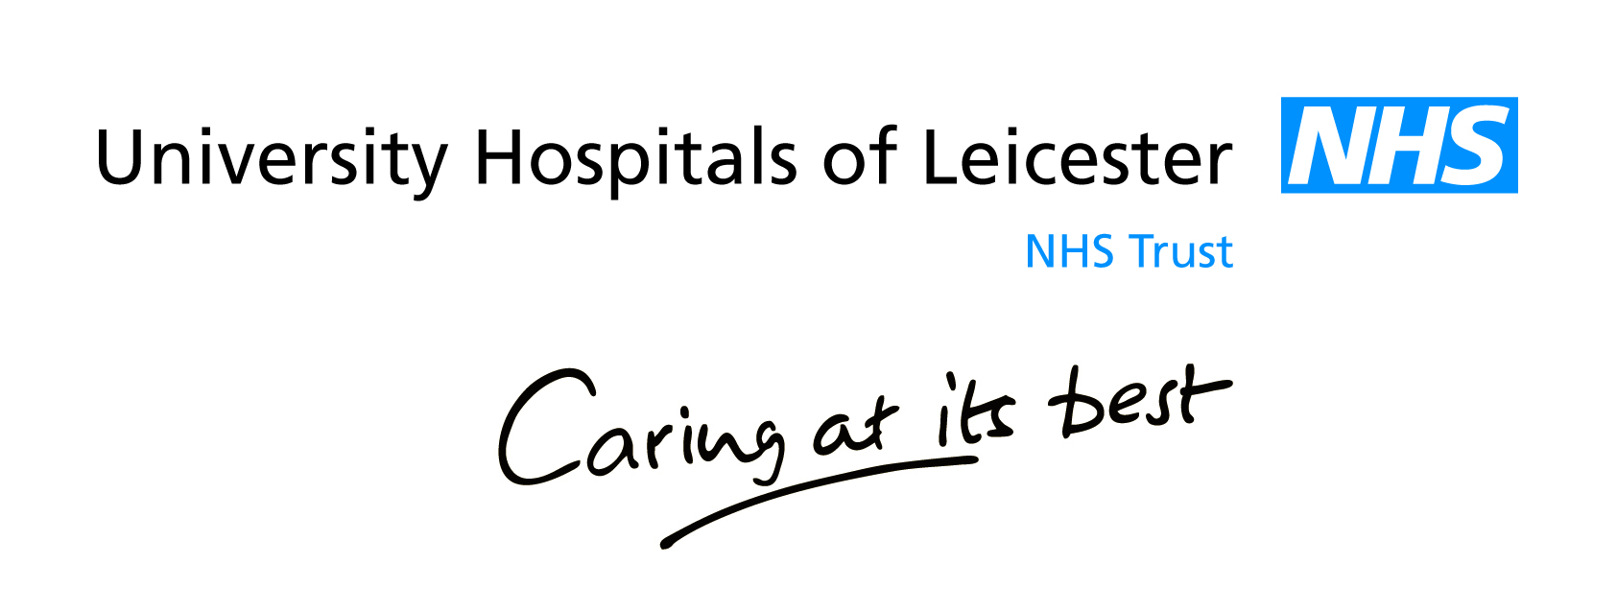
List of Contracts Awarded and their Value

Click on the link below for access to UHL’s List and Value of Contracts Awarded:

https://www.supplying2nhs.com/procontract/healthservice/portal_contracts.nsf/fcontent?ReadForm&requesttype=view&requestview=authority&start=1&count=10&contentid=1.002

